## MINI PROJECT REPORT

**on**

**AUDIOBOOK**

**Submitted in partial fulfilment for the completion of**

**BE-III Semester**

**In**

**INFORMATION TECHNOLOGY**

**By**

**D.BALU CHANDER (160117737153)**

**V.BHARGHAV (160117737154)**

**Under the guidance of**

**Mrs. B. Sarada**

**Assistant Professor,**

**Dept. of IT, CBIT.**



**DEPARTMENT OF INFORMATION TECHNOLOGY**

**CHAITANYA BHARATHI INSTITUTE OF TECHNOLOGY (A)**

**(Affiliated to Osmania University; Accredited by NBA(AICTE) and NAAC(UGC), ISO Certified 9001:2015)**

**GANDIPET, HYDERABAD – 500 075**

**Website:** [**www.cbit.ac.in**](http://www.cbit.ac.in)

**2019-2020**

**CHAITANYA BHARATHI INSTITUTE OF TECHNOLOGY (A)**

DEPARTMENT OF INFORMATION TECHNOLOGY

**(Affiliated to Osmania University)**

**GANDIPET, HYDERABAD – 500 075**



**CERTIFICATE**

This isto certify that the project work entitled “**AUDIOBOOK**” submitted to **CHAITANYA BHARATHI INSTITUTE OF TECHNOLOGY,** in partial fulfilment of the requirements for the award of the completion of III semester of B.E in Information Technology, during the academic year 2020-2021, is a record of original work done by D.BALU CHANDER (160117737153) and V.BHARGHAV (160117737154) during the period of study in Department of IT, CBIT, HYDERABAD, under our supervision and guidance.

**Project Guide**  **Head of the Department**

**Mrs. B. Sarada Dr.Radhika**

Professor, Dept. of IT, Professor, Dept. of IT,

CBIT, Hyderabad. CBIT, Hyderabad.

**CONTENTS**

**Pg. no.**

**ACKNOWLEDGEMENT 4**

**ABSTRACT 5**

**LIST OF FIGURES 6**

**LIST OF SCREENSHOTS 6**

1. **INTRODUCTION 7**
   1. Motivation
   2. Basic Definition
   3. Problem Statement
2. **EXISTING SYSTEM 8**

1. **PROPOSED SYSTEM** 
   1. Methodology **9**
   2. Architecture of Proposed System **10**
2. **SOF****TWARE & HARDWARE REQUIREMENTS 14**
3. **IMPLEMENTATION OF PROJECT 14**
   1. Results
   2. Screen Shots
4. **CONCLUSION & FUTURE SCOPE 16**
5. **BIBILOGRAPHY 16**

**ACKNOWLEGEMENTS**

We would like to express our deep and sincere gratitude to our project guide, Mrs. B. Sarada for giving us the opportunity to do the project and providing her invaluable guidance throughout this project. It was a great privilege and honour to work and study under her guidance.

We would like to thank to our Head of Department, Dr. Radhika for giving us the opportunity to improve our skills, for constant support, and provided us with the sources that are required for the completion of this project.

Our sincere thanks to the Principal Dr. G. P. Saradhi Varma, as well as the management of the institute, for giving us a good opportunity to improve our skills with a good learning atmosphere.

We are extremely grateful to our parents for their love, prayers, caring and sacrifices for educating and preparing for our future and supported us in the completion of this project.

We would like to thank our friends for their constant help and guidance and for their support in completion of this project.

Our thanks to all members of the staff and to lab assistants for helping us carry out the groundwork of this project and their timely support.

**Abstract**

Reading stories or essays or any text can be arduous,however an audio reading the text is convenient and doesn’t require as much concentration as reading.An audio book allows us to listen to a recording of the text , rather than reading the text .As we always find it very hard to read out the entire text in a pdf file , so in this project we created an audio book which reads out our pdf file. Now instead of reading we can do other works while listening to it.

Steps for executing the solution of the problem:

1.We need to import the packages required.

2.We should provide the pdf file location as input.

3.Next using the functions we have to read the pdf file.

4.Then we have to specify the page number required if it consists of multiple pages.

5.Next the function extracts the page and converts it into an audio clip.

The algorithm is written in Python language.

**V.BHARGHAV**

(160119737154)

**D.BALUCHANDER**

(160119737153)

**LIST OF FIGURES**

|  |  |  |
| --- | --- | --- |
| **Figure** | **Description** | **Page No.** |
| **Fig. 1.1** | **Flowchart** | **9** |

**LIST OF SCREENSHOTS**

|  |  |  |
| --- | --- | --- |
| **Screenshot** | **Description** | **Page No.** |
| **Screenshot 1.1** | **Selection of choices** | **14** |
| **Screenshot 1.2** | **Speech to text input** | **15** |
| **Screenshot 1.3** | **Speech to text output** | **15** |
| **Screenshot 1.4** | **Text to speech output** | **15** |
| **Screenshot 1.5** | **Audiobook output** | **16** |

**1.INTRODUCTION**

The project “AUDIOBOOK” is a recording of a book or other work being read out loud. A reading of the complete text is described as "unabridged", while readings of a shorter version are an abridgement.

Spoken audio has been available in schools and public libraries and to a lesser extent in music shops since the 1930s. Many spoken word albums were made prior to the age of cassettes, compact discs, and downloadable audio, often of poetry and plays rather than books. It was not until the 1980s that the medium began to attract book retailers, and then book retailers started displaying audiobooks on bookshelves rather than in separate displays.

* 1. **Motivation**

As technology is advancing at lightning speed, with that people are getting more addicted to mobile phones, tablets & other smart devices. Carrying a phone is a must these days and people spend most of their time on the mobile rather than books. The importance of having an audio book mobile  has climbed the ladder to the top as many are enthusiastic in using it. This is the primary reason to opt making a audio book of my own. This application can provide the features of reading an pdf fie or reading a particular page of it.

* 1. **Basic Definition**

An audiobook allows a person to listen to a recording of the text of the book, rather than read the text of the book.These days, audio books are simply downloaded as digital audio files in formats such as MP3, WMA (Windows Media Audio), or AAC (Advanced Audio Coding).

**1.3 Problem Statement**

The main objective of this project is to create an audio book that can provide a place for many people to start listening their pdfs rather than reading it by themselves. It saves a lot of time.

**2. EXISTING SYSTEM**

While these have dramatically risen in popularity over the last few years alone, they’re not exactly new. Audiobooks, or “talking books," as they were often referred to in the past, emerged during the 1930s. Unlike the digital versions we enjoy today, however, they often came in the physical form of a cassette tape or vinyl record and were mostly used for educational purposes at schools or libraries.

These days, audiobooks are simply downloaded as digital audio files in formats such as MP3, WMA (Windows Media Audio), or AAC (Advanced Audio Coding). These can then be listened to from any electronic device that supports streaming audio, such as a phone, computer, or tablet.

Some of the most common websites and apps people use to find and purchase audiobooks include:

* Apple Books
* Audible.com
* Nook Audiobooks
* Google Play Books
* Kobo

Studies reveal that audiobook sales are growing by 25% year-over-year, with the number of global audiobook listeners currently exceeding half a billion. So, why are audiobook sales booming and what made them suddenly so popular?

According to research, the audiobook’s success can be linked primarily to digital media. A staggering 91.4% of 2018's $940 million in US audiobook revenue came entirely from digital formats (i.e. MP3s), as opposed to physical formats such as CDs.

**3.PROPOSED SYSTEM**

**3.1 METHODOLOGY**

The proposed system is designed to convert a pdf file to a mp3 file, even it has facilities like text to speech converter and speech to text converter which changes the user input to respective formats .The user has an option to choose among text to speech converter, speech to text converter and audio book converter.

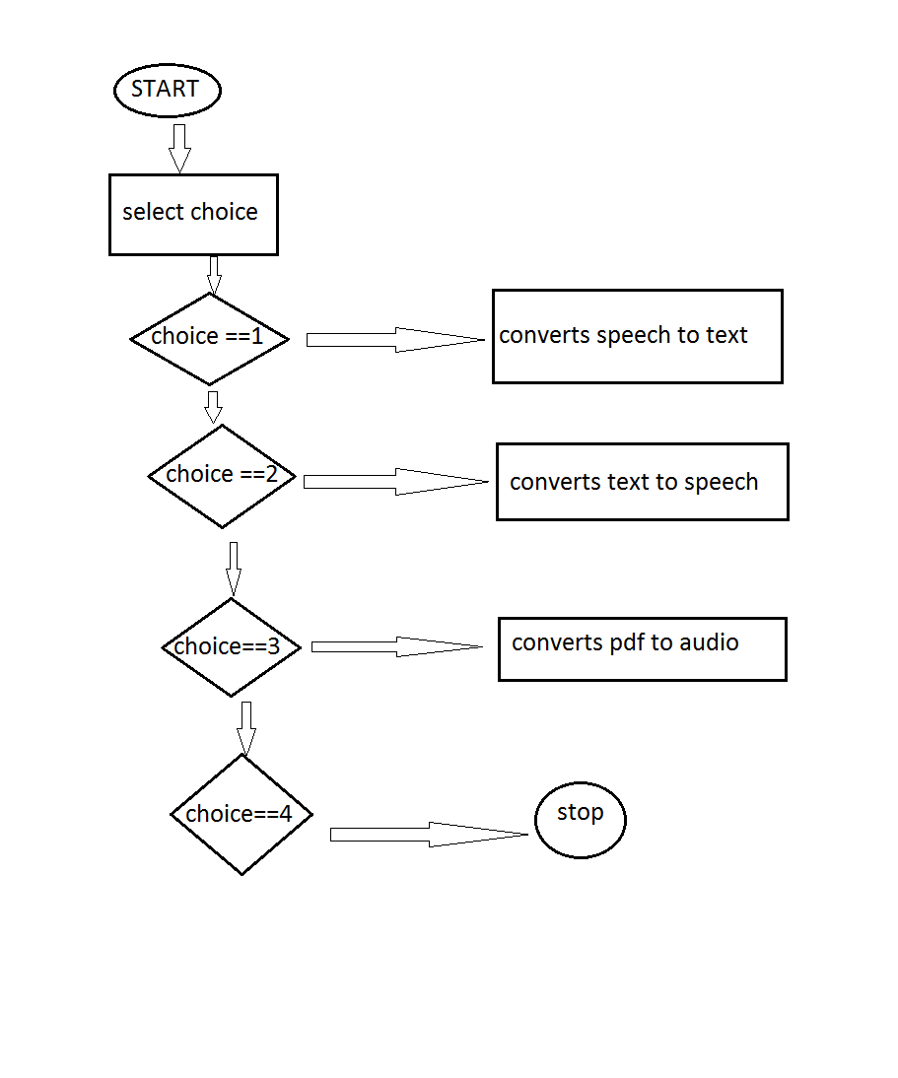

**Fig 1.1**

If the user selects text to speech the application converts the required text into an mp3 file and asks whether to play it or not ,and if the user selects speech to text the application asks to speak something, recognises it and speaks out for us and the last one if the user selects audio book it converts the pdf file given to it into an mp3 file and asks whether to play it or not. It also has the exit option which ends our application.

**3.2 Architecture of Proposed System**

import curses

import speech_recognition as sr

from gtts import gTTS

import os

import pdfplumber

menu = ['Speech-To-Text','Text-To-Speech', 'Audio Book', 'Exit']

def print_menu(stdscr, selected_row_idx):

stdscr.clear()

h, w = stdscr.getmaxyx()

for idx, row in enumerate(menu):

x = w//2 - len(row)//2

y = h//2 - len(menu)//2 + idx

if idx == selected_row_idx:

stdscr.attron(curses.color_pair(1))

stdscr.addstr(y, x, row)

stdscr.attroff(curses.color_pair(1))

else:

stdscr.addstr(y, x, row)

stdscr.refresh()

def print_center(stdscr, text):

stdscr.clear()

h, w = stdscr.getmaxyx()

x = w//2 - len(text)//2

y = h//2

stdscr.addstr(y, x, text)

stdscr.refresh()

def app(stdscr,current_row):

stdscr.clear()

if current_row== 0:

r=sr.Recognizer()

with sr.Microphone() as source:

print_center(stdscr,"say something")

audio=r.listen(source)

try:

text=r.recognize_google(audio)

print_center(stdscr,"you said : {}".format(text))

except:

print_center(stdscr,"couldnt recognize")

elif current_row==1:

text="Hi what are you doing"

language='en'

output=gTTS(text=text,lang=language,slow=False)

output.save("output.mp3")

print_center(stdscr, "Your text is converted.Do you want to play it.")

key=stdscr.getch()

if key==ord('y'):

os.system("start output.mp3")

elif current_row==2:

pdf_path = "ARTIFICIAL INTELLIGENCE.pdf"

pdf = pdfplumber.open(pdf_path)

page = pdf.pages[1]

text = page.extract_text()

pdf.close()

language = 'en'

gtts_transformer = gTTS(text=text, lang=language)

gtts_transformer.save("audiobook.mp3")

print_center(stdscr, "Your audio book is created.Do you want to play it.")

key=stdscr.getch()

if key==ord('y'):

os.system("start audiobook.mp3")

stdscr.refresh()

def main(stdscr):

# turn off cursor blinking

curses.curs_set(0)

# color scheme for selected row

curses.init_pair(1, curses.COLOR_BLACK, curses.COLOR_WHITE)

# specify the current selected row

current_row = 0

# print the menu

print_menu(stdscr, current_row)

while 1:

key = stdscr.getch()

if key == curses.KEY_UP and current_row > 0:

current_row -= 1

elif key == curses.KEY_DOWN and current_row < len(menu)-1:

current_row += 1

elif key == curses.KEY_ENTER or key in [10, 13]:

app(stdscr,current_row)

stdscr.getch()

# if user selected last row, exit the program

if current_row == len(menu)-1:

break

print_menu(stdscr, current_row)

curses.wrapper(main)

## 4.SOFTWARE & HARDWARE REQUIREMENTS

|  |  |
| --- | --- |
| Operating System | Windows XP ,windows 7/8/10 |
| Programming Language | Python |
| Other Applications | Visual Studio Code or Pycharm |
| Processor | Intel(R) Core(TM) i3 CPU M 350 @2.27GHz |
| RAM | 512 MB |
| Disk Space | 300 KB |

Table 4.1: Software & Hardware Requirements

**5.IMPLEMENTATION OF PROJECT**

**RESULTS**

As the result of the program we get three results based on the user choice if user selected ,

1.Text to speech then the user gets a mp3 file as output which has his text converted into audio.

2. Speech to text then user gets to see the text on the console which he spoke.

3.Audio book then user gets the mp3 file of his pdf

**SCREENSHOTS**

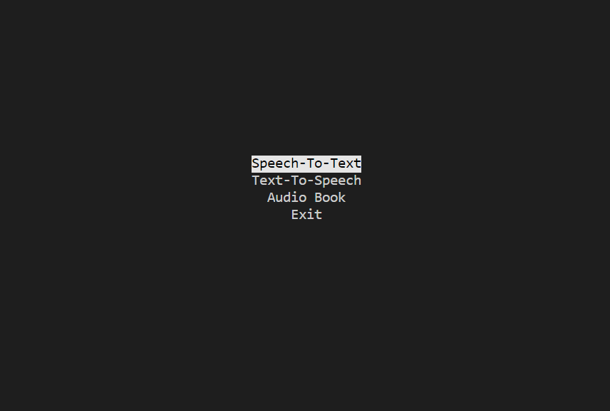

Screenshot 1.1

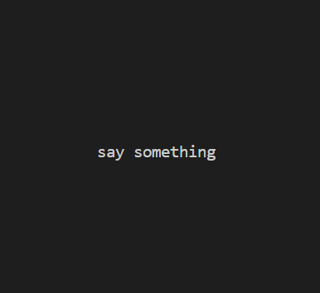

. Screenshot 1.2

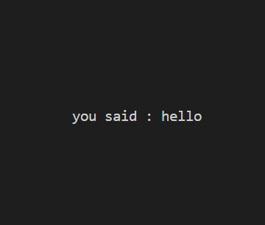

Screenshot 1.3

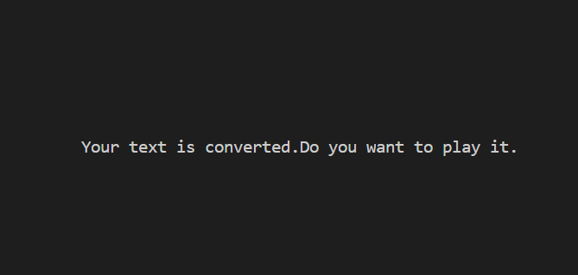

Screenshot 1.4

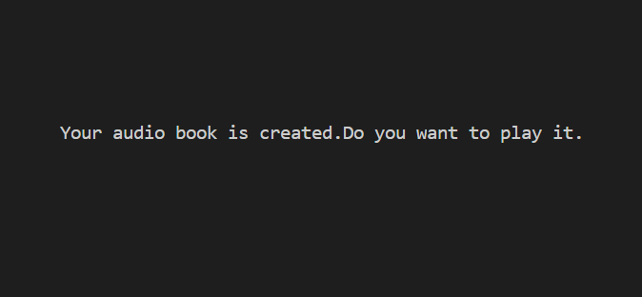

Screenshot 1.5

**CONCLUSION AND FUTURE DRAFT**

This mini project successfully converts the given input which may be text or pdf into mp3 file and inputs like audio into text format. Audiobooks have been used to teach children to read and to increase reading comprehension. They are also useful for the blind. Already a highly coveted and popular format internationally, audiobooks are the just the thing you have been looking for, as far as decent readership and better reach of your work, is concerned.

There is no doubt about the fact that audiobooks are the future of books.

**BIBILOGRAPHY**

1. https://en.wikipedia.org/wiki/Audiobook/
2. https://towardsdatascience.com/build-your-own-audiobook/
3. <https://www.quora.com/>
4. <https://github.com/>